

Digital patient panel

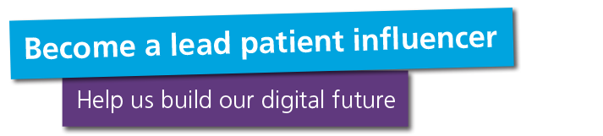

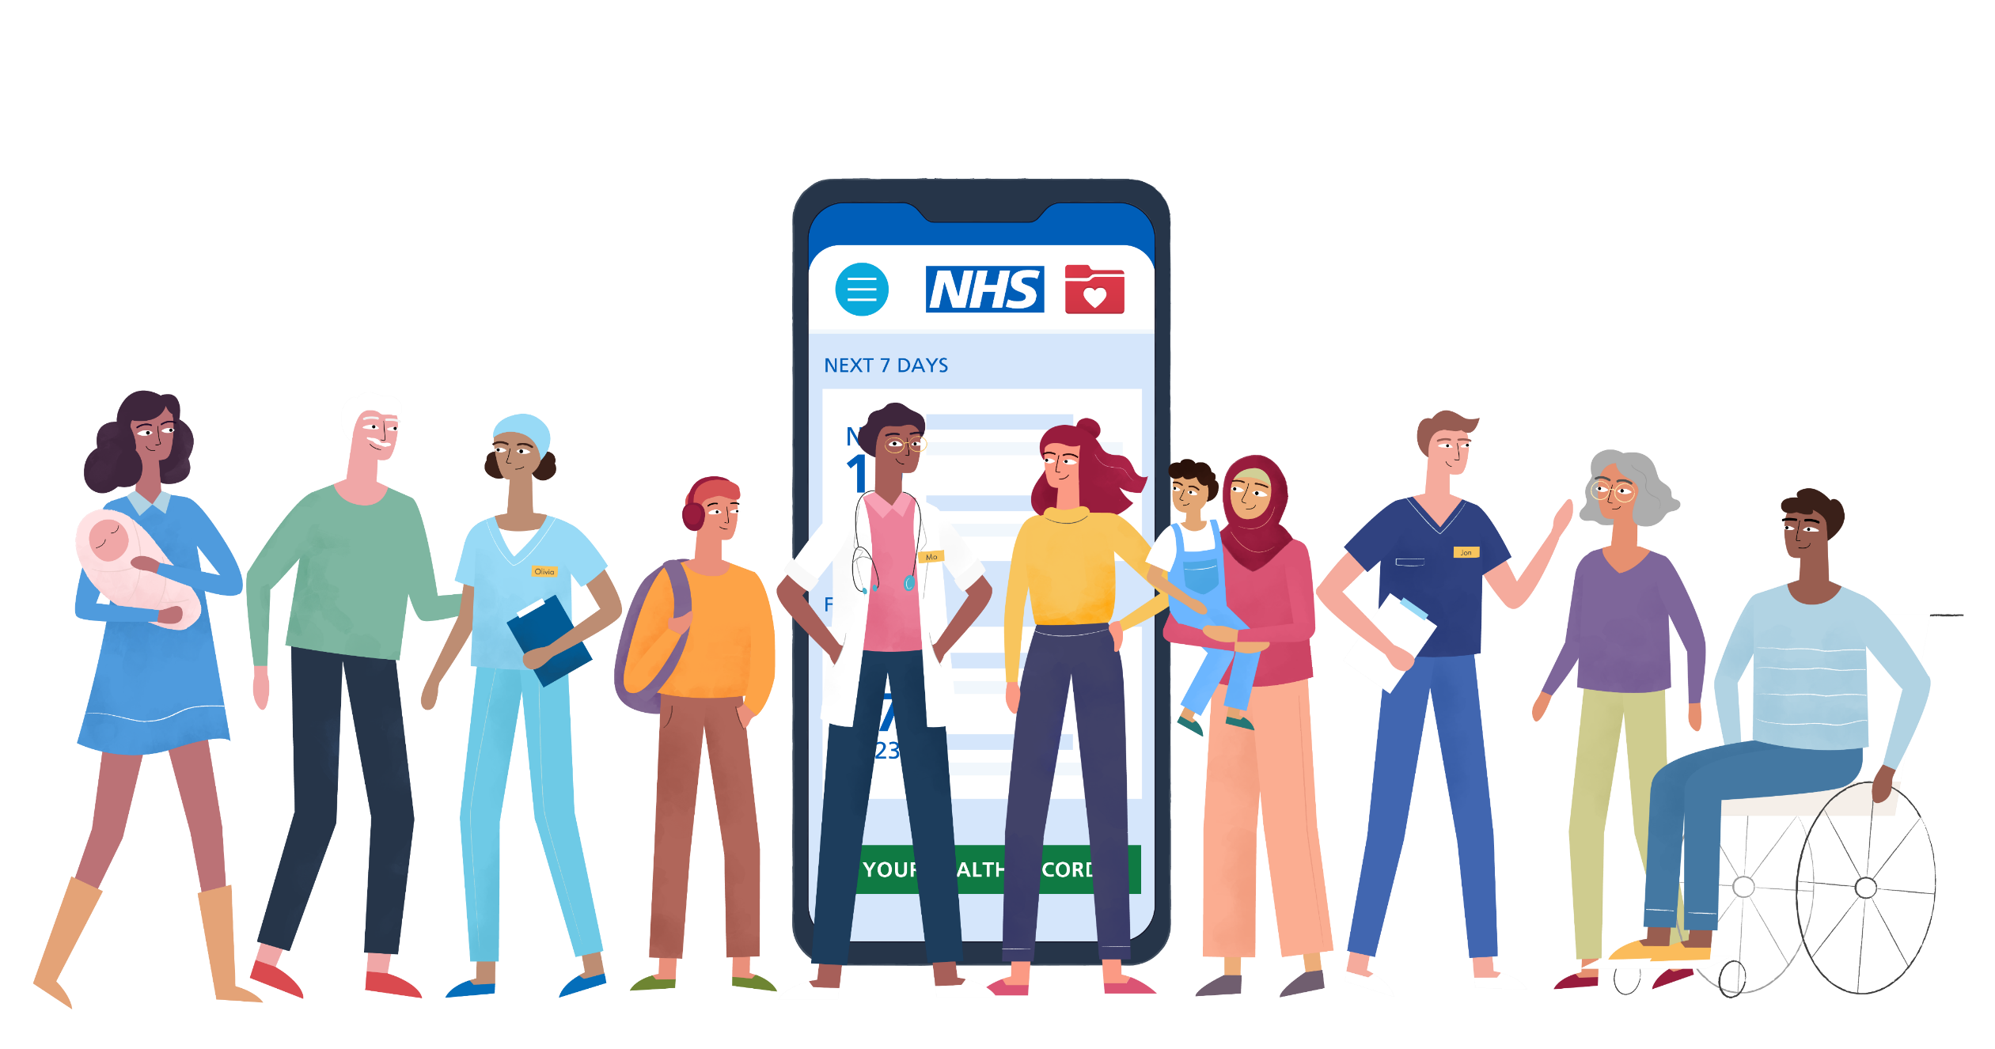

Position: | Lead patient influencer, member of the digital patient panel
Staff contact: | General digital patient panel enquiries: Laura James, lead for patient involvement in digital development (patient and public engagement specialist, Guy’s and St Thomas’)  Project-specific contacts: these will be shared after you have shown your interest in an activity, and then we have confirmed you are taking part.
Estimated time commitment: | 1.5 days a month, on average.  This is based on completing one survey, attending one workshop, preparing to present at a patient feedback session, and presenting at a patient feedback session  Go to the What will we ask you to do? section on page 4 to find out more about the flexibility of this role, and the options available to you.
Preparation time: | We will give you all the information you need in each activity, but we can send information to you ahead of time if that is helpful.  Lead patient influencers will also be required to attend patient feedback sessions to act as a representative of the wider patient panel and report on findings. You may be required to read papers and prepare for these events ahead of time.
Length of events and meetings: | This will depend on the activity, but here are some examples  - Surveys will be around 5-10 minutes  - Workshop meetings are between 1 hour and 2.5 hours (plus breaks)  - Patient feedback sessions where you will represent the patient panel will be between 30 minutes and 1 hour  - Other patient panel events will be between 1 and 1.5 hours

What is the digital patient panel?
We know that the best digital healthcare can only be built by working with you – our patients, carers, family members, and anyone else who supports our patients.
Join our panel and make a difference by helping us to design and improve digital services across Guy’s and St Thomas’ and King’s College Hospital.
You will help us:
- Understand the needs and experiences of people from a wide range of backgrounds
- Test digital tools and find ways to make them work better
- Design new digital functions and tools
- Create clear and accessible supporting information

Who are we looking for?

Digital patient panel members
All panel members will be 16 or over and will have been a patient or carer of Guy’s and St Thomas’ or King’s College Hospital at some point in the last 5 years. This includes accessing services at one or more of the following:
- Guy’s Hospital
- St Thomas’ Hospital
- Royal Brompton Hospital
- Harefield Hospital
- Evelina London Children’s Hospital
- King's College Hospital
- Princess Royal University Hospital
- Beckenham Beacon
- Orpington Hospital
- Queen Mary's Hospital
- Guy’s and St Thomas’ community services and sexual health services
- King’s College Hospital community services and sexual health services

We would particularly like to have digital patient panel representation across the following groups:
- people with all levels of digital confidence, from low to high
- over 75s
- people have who English as an additional language
- people who have disabilities, and their carers

Applicants between the ages of 16-18 will need written permission from a parent, guardian or carer in order to take part.

Lead patient influencers

In addition to what we ask of all digital patient panel members, lead patient influencers will also:
- have some understanding and interest in how digital technology can be used in healthcare
- have experience in leadership or chairing meetings
- have experience managing groups of people, either at work, school, or in their local community

They will have:

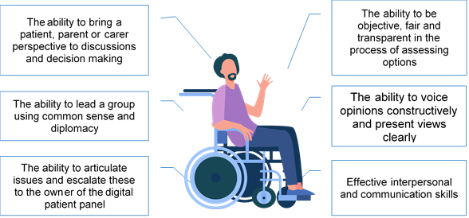

What will you do?
As part of the lead patient influencer role, you will need to:
- apply to take part in digital patient panel activities when possible
- prepare for patient feedback sessions – this will include reading reports of activities you have taken part in
- present and have discussions about report findings with Trust staff
- represent your own views and the views of the wider digital patient panel in patient feedback sessions
- where appropriate, prepare for engagement activities or patient feedback sessions by reading any relevant information provided
- be willing to undertake appropriate training, development and support activities that are offered

How will we support you in this role?
We offer you:

- Lots of different opportunities for involvement: We will contact you with available opportunities. You can then tell us which you would like to take part in.
- Flexible participation: you can get involved as much or as little as you want. There will be a mix of online and face-to-face options.
- Updates on impact: we will provide updates on how your involvement has made a difference.
- Career and educational development: you will get a chance to learn about and take part in digital design processes.
- Reimbursement of expenses: we will reimburse your out-of-pocket expenses in line with Trust policy.
- Support to take part: we will ask you if there is any additional support you need to get involved

Some of the ways we can support you to take part include:
- help you to facilitate discussions
- support you to lead or act as chair in discussions
- help you to prepare for patient feedback sessions
- answer any of your questions ahead of meetings and workshops
However, if there is something else you need, please tell us on your application form and we will do our best to help.
Depending on the type of activity you take part in, you also may be reimbursed and rewarded in one or more of the following ways:

- Public and other types of transport reimbursement
- Childcare reimbursement
- Paid carer reimbursement
- Internet data add-on reimbursement
- Monetary payment
- Foundation Trust membership
- Job and education references

If you are successful in applying to take part in a particular activity, we will then let you know which types you can claim for. All reimbursement and reward will be in alignment with Guy’s and St Thomas’ policy.

Next steps
If you are ready to apply, please complete the online application form.

If you would like to have an informal conversation about the role, or request the form in a different format, please contact:

- Laura James, Patient and Public Engagement Specialist (Guy’s and St Thomas’)
- T: 07824 364 480
- E: laura.james46@nhs.net

