|  |  |
| --- | --- |
| **Board Briefing** | http://gti/resources/communications/logos-and-templates/a6-guys-and-st-thomas-rgb-blue.jpg |
| **Board Briefing of Nursing and Midwifery Staffing Levels** | **Date of Briefing**  December 2019 (November 2019 data) |
|  |  |

|  |  |  |  |  |  |
| --- | --- | --- | --- | --- | --- |
| This paper is for: |  | | Sponsor: | **Dame Eileen Sills (DBE), Chief Nurse and Deputy Chief Executive** | |
| Decision |  |  | Author: | **Workforce Team (Chief Nurse’s Office)** | |
| Discussion |  |  | Reviewed by: | Toni Lynch, Deputy Chief Nurse | |
| Noting |  |  | CEO* |  |  |
| Information | ✓ |  | ED* |  |  |
|  | | | Board Committee* |  |  |
| TME* |  |  |
| Other* |  |  |
|  |  | |

1. **Summary**

This briefing provides the Trust Board with an overview of the Nursing and Midwifery workforce during the month of November 2019 and is set out in line with the National Quality Board (NQB) Standards and Expectations for Safe Staffing published in 2016.

It provides assurance that arrangements are in place to safely staff our services with the right number of nurses and midwives with the right skills, at the right time.

1. **Key highlights for November 2019**

|  |
| --- |
| * The nursing and midwifery vacancy rate this month remains the same as in the previous month at 14.3%. It was 12.0% in the same period last year. The rise over the past year is driven by the increase in the overall nursing and midwifery establishment (additional 626.86 WTE posts). There continues to be an increase in the number of staff in post with 90.14 more WTE compared to October and an additional 387.67 WTE since November 2018. If the current external applicants in the pipeline were added to the staff in post figure, the overall vacancy rate would be 10.1%, which represents 0.9% increase from last month. |
| * Agency spend rate increased from 4.9% to 5.1% representing a 0.2% increase this month. |
| * Monthly Voluntary Turnover reduced this month from 1.6% to 1.2%. The annual voluntary turnover also reduced significantly to 12.2% which represents a 3% reduction over the last 12 months since December 2018. |
| * Sickness absence rate remained the same at 4.3% as in previous month. Nursing and midwifery staff within the Training and Education, Human Resources and Dental Services Directorates recorded the highest sickness rates with 9.1%, 7.4% and 6.5% respectively. |
| * Personal Development Review (PDR) compliance rate increased slightly this month from 82.1% to 82.8% representing a 0.7% increase. Of note it has increased by 1.5% compared to November 2018. |
| * Mandatory training compliance increased by 0.5% to 88.0%, it was 84.5% for the same period last year. |

1. **EXPECTATION 1 – RIGHT SKILLS**

**3.1 Evidence Based Workforce Planning**

In order to ensure the safe and effective delivery of patient care, it is essential that we have the right establishment and the right staff in post. Table 1 sets out the current overall nursing and midwifery workforce metrics in comparison to November 2018, table 2 identifies the growth in establishment (9.67%) compared to the growth of staff in post (6.79%) and table 3 sets out the growth of staff in post.



***Table 1***

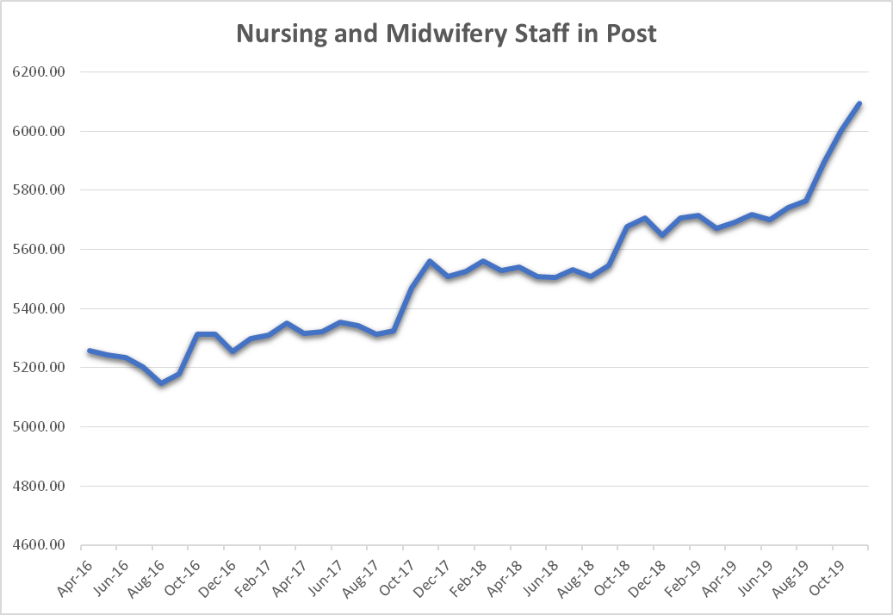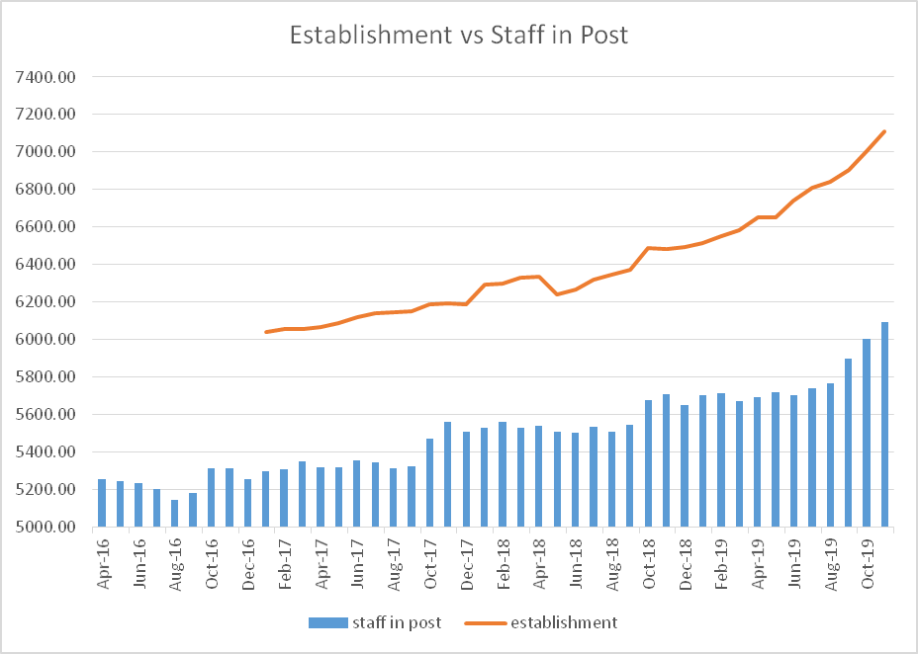

***Table 2 Table 3***

**3.2 Recruitment and Retention**

Tables 4, 5 and 6 display the trends in three key nursing and midwifery workforce metrics, namely vacancy, turnover and sickness.

Active recruitment strategies continue, including the three weekly assessment centres for Band 5 staff and six weekly assessment centres for Band 2 staff. There continues to be a healthy pipeline of new starters waiting to join the Trust although this has now reduced overall due to large numbers joining in October and November.

There was a successful Trust Open Day held on 29th November which saw over 300 potential candidates come to the Trust and engage in conversations with all Directorates. There were a number of candidates who interviewed successfully on the day who will be joining the Trust in the coming weeks. The process for recruiting host and non-host student nurses has commenced, with a number of non-host students invited for interview on 6th January. The process for host students has been refined for this year to ensure a seamless transition.

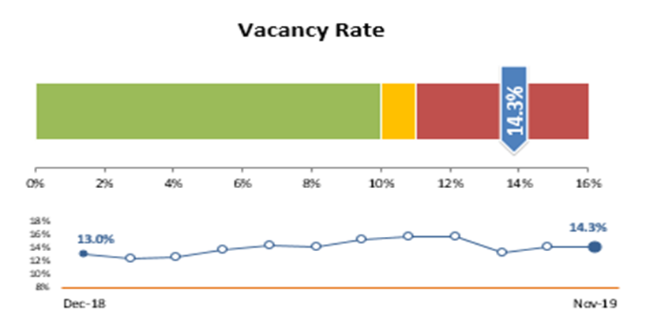 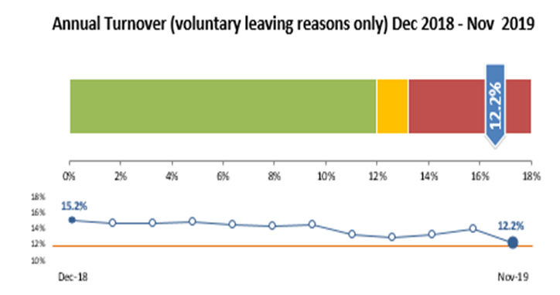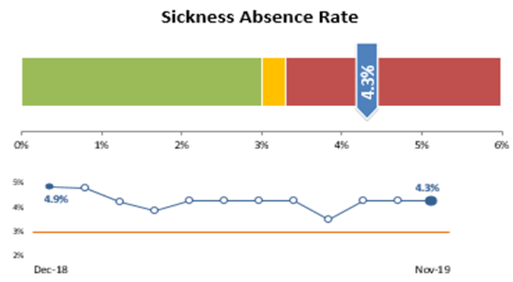

***Table 4 Table 5 Table 6***

**3.3 Activity and Acuity**

The number of bed days in November 2019 stood at 47,208 (Table 7). This is 1,214 less than the previous month and represents a decrease of 2,646 bed days from the same period in 2018 which demonstrates a 5.31% reduction in activity. From an acuity perspective, Level 1b (heavily dependent or acutely unwell) patients in non-critical care beds, continues to be the most prevalent acuity score across the Trust which is consistent with the past few years.

***Table 7***

The average fill rate for registered staff was 94.5% in comparison to an unregistered staff average fill rate of 117.0%, with an overall fill rate of 98.7%. There are times when it is appropriate to utilise unregistered staff to support safe staffing in the absence of registered staff. Heads of Nursing, Matrons, Site Nurse Practitioners and Ward Leaders make operational patient safety decisions on a shift by shift basis to ensure all areas are safely staffed.

Safe Staffing meetings continue to be held on Friday mornings, with Senior Nursing representation, in order to ensure that all areas are safely staffed over the weekends, with additional meetings held over the Christmas and New Year period.

The Trust average ‘Care hours per patient day’ (CHPPD) was 11.2 for the month of November. This figure is reported monthly to NHSI as required and is a national metric based on the number of hours of nursing and midwifery care used, divided by the number of patients in beds at 12 midnight for the month. The peer (Shelford Group) average, benchmarked on Model Hospital is 9.2. As reported in previous months, there had been a rise in the CHPPD within Critical Care at St Thomas’ which is reflective of reduced bed capacity to facilitate refurbishment of the clinical areas. As the capacity is now beginning to increase, the level of CHPPD is reducing and it is anticipated to be back within normal limits once full capacity is reinstated.

1. **EXPECTATION 2 – RIGHT SKILLS**

**4.1 Mandatory Training, Development and Education**

The current compliance with mandatory training across the nursing and midwifery workforce is 88.0%. This has increased by 0.5% from the previous month. Table 8 demonstrates the breakdown of compliance at Directorate level. All establishments have an uplift built in to support staff with undertaking their mandatory training and development whilst maintaining safe levels of staffing.

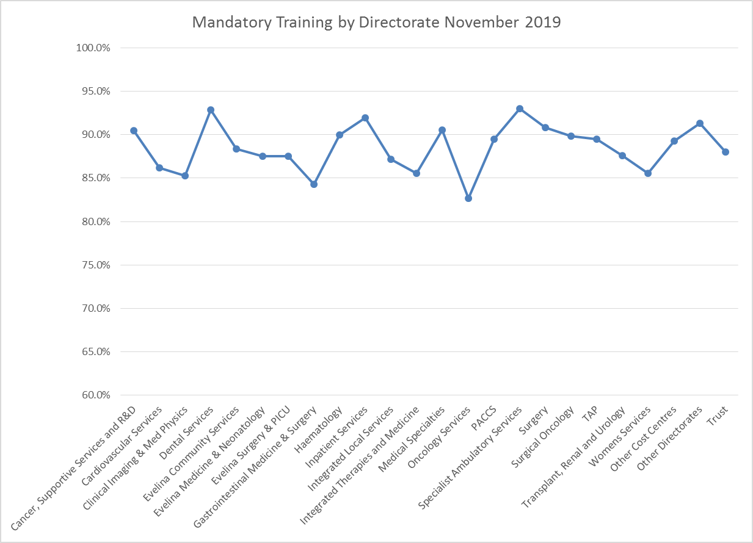

***Table 8***

***Table 8***

The current PDR rate across the nursing and midwifery workforce is 82.8% which is an increase of 0.7% from the previous month and 1.5% higher than at the same time in 2018. Compliance with completion of PDRs at Directorate level is shown in Table 9. All areas are monitored on their PDR rates through the Directorate Performance Review Meetings (PRMs).

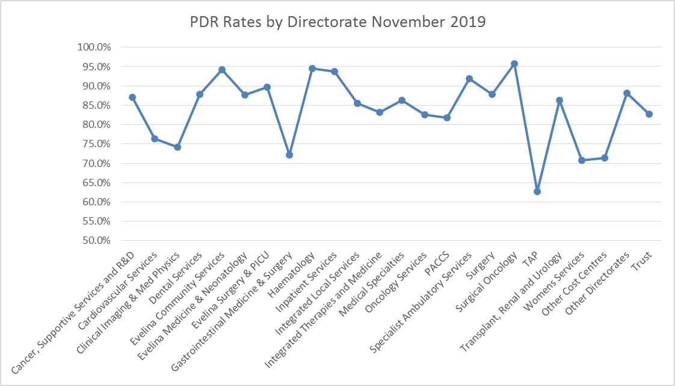

***Table 9***

**4.2 Nursing Associate programme**

The Nursing Associate programme continues to expand with workforce redesign facilitated within the individual Directorates/Strategic Business Units as part of their annual establishment reviews and through engagement work with establishment planning and redesign utilising desk top simulation. Results of this work will show the numbers of Nursing Associates required within each clinical area and future Apprentice Nursing Associate numbers are to be submitted as part of Directorate/SBU business planning 2020/21.

The Nursing and Midwifery Council (NMC) has approved the Trust’s partnership with Coventry University London for both the Direct Entry model, commencing May 2020, and the Apprenticeship Nursing Associate course, commencing January 2020. The NMC commended the breadth and variety of the student placements available and the true partnership working between the Trust and Coventry University London.

Of the 123 funded Apprentice Nursing Associate posts within the Trust, 87 remain in training, 2 have withdrawn from the course (1 to apply for nurse degree training and 1 for personal reasons), 26 are due to commence in January, 3 candidates are receiving Maths and English support prior to enrolment and a further 5 candidates still to be recruited.

**5.0 EXPECTATION 3: RIGHT PLACE AND TIME**

**5.1 Efficient Deployment and Flexibility**

The Safe Care application, across all adult and children’s inpatient areas, supports the real time visibility of staffing levels across the Trust. The collection of the data highlights and supports decision making relating to the deployment of temporary staff or the need to move staff to support patient needs in other areas. Maternity Services continue to use Safe Care for staff check-in and red flag functionality.

In November 2019, there was a decrease of 2 red flags raised by staff highlighting concerns with staffing levels compared to the previous month. Table 10 shows the distribution of red flags and the comparison to October 2019 (51 red flags in October, 49 red flags in November). Staff are encouraged to raise red flags when there are concerns relating to safe staffing levels.

The Trust is taking part in the NHSI Healthcare Support Worker Vacancy Reduction programme, as part of this, we aim to streamline occupation coding to enhance data quality and promote a more efficient and effective vacancy reduction plan, promoting continuous safe staffing and a reduction in agency spend.

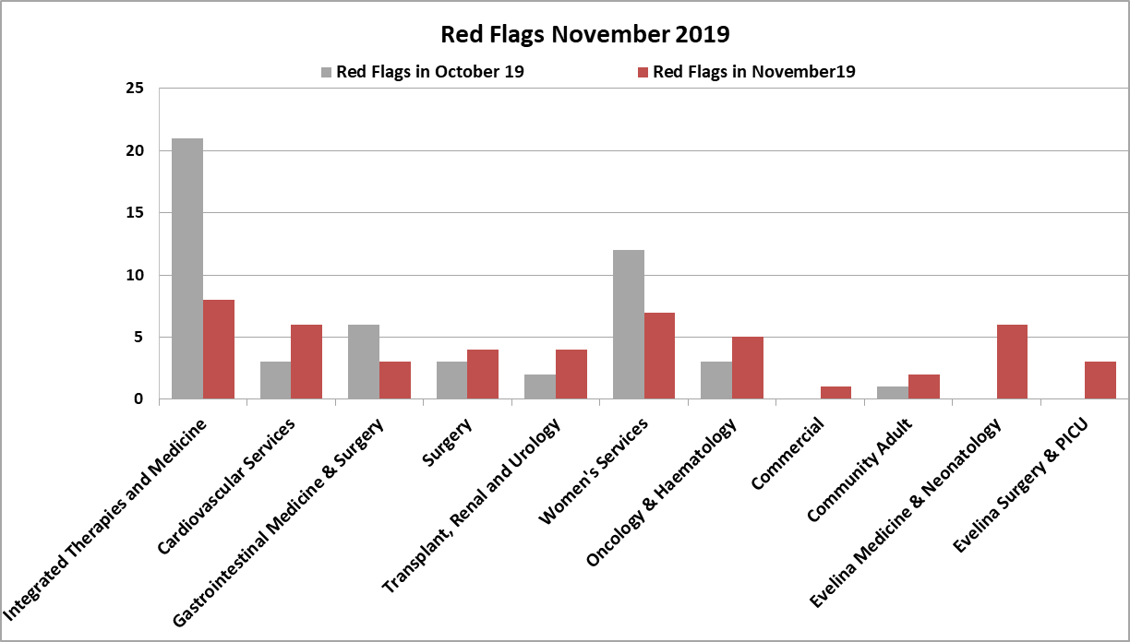

***Table 10***

**5.2 Efficient Employment, Minimising Agency Use**

Since January 2018, all Directorates have engaged with roster challenge boards which are designed to improve rostering against agreed Key Performance Indicators (KPIs). These are being led by the Chief Nurse Workforce team to ensure that all areas are producing effective, fair, safe and efficient rosters. There has been a significant amount of work undertaken to add new areas onto Health Roster e.g. Dental Services and CLIMP, and to ensure rosters are properly allocated on Health Roster.

**All nursing areas**

**10th Sep -**

**7th Oct**

**8th Oct -**

**4th Nov**

**5th Nov -**

**2nd Dec**

**3rd - 30th**

**Dec**

**31st Dec -**

**27th Jan**

**28th Jan -**

**24th Feb**

**25th Feb-**

**24th Mar**

**25th**

**March-**

**21st Apr**

**22nd**

**April -**

**19th May**

**20th May**

**-16th**

**June**

**17th June**

**-14th July**

**15th July -**

**11th**

**August**

**12Aug-**

**8th Sep**

**9thSep-**

**6thOct**

**7th Oct -**

**3rd Nov**

**4th Nov -**

**1st Dec**

Planned Hours

583,188

588,827

589,675

590,355

600,409

633,300

641,701

639,480

641,592

646,070

711,507

652,685

655,325

665,526

670,407

691,499

Actual Hours

539,042

541,510

551,757

521,209

538,871

576,540

572,925

568,448

580,969

581,757

696,731

583,265

565,353

589,519

873,659

613,806

Actual CHPPD

8.6

8.8

8.9

9.3

9.6

10.1

10.2

11.0

9.8

9.8

11.7

11.8

11.4

16.6

8.9

11.5

Required CHPPD

8.3

8.3

8.3

8.3

8.3

8.3

8.0

8.1

8.4

8.3

7.3

8.4

8.6

6.8

6.4

7.2

Additional Duties (No of

shifts over budget)

4,918

5,007

4,972

4,629

5,015

5,100

5,022

5,412

5,830

5,626

5,756

5,812

5,844

6,132

5,726

5,486

Overall Owed Hours (Net

Hours)

149,592

115,128

163,134

172,017

158,745

132,208

91,888

97,569

96,125

103,004

113,245

119,384

117,139

138,948

118,325

106,178

Annual Leave % - Target 11-

17%

11.7%

11.6%

11.2%

13.4%

12.7%

13.9%

16.6%

14.6%

11.5%

12.3%

11.5%

13.9%

17.5%

10.3%

11.3%

10.3%

Total Unavailability % -

Headroom/uplift

Allowance - Target 24%

25.9%

26.0%

24.7%

26.3%

25.6%

26.2%

28.0%

27.0%

23.9%

24.3%

23.4%

23.0%

28.3%

25.1%

27.1%

25.8%

Roster Approval (Full) Lead

Time Days - Target 42 days

31

24

34

38

65

48

40

42

40

42

46

45

43

42

42

43

***Table 11 Data from September 2018 – December 2019***

Table 11 demonstrates the main KPIs and other key metrics relating to the efficient deployment of staff at Trust level for rosters covering the last year. The overall roster lead time has demonstrated consistent improvement throughout 2019 and there has been a 21.7% overall reduction in the number of “net” or “owed” hours.

Having efficient rosters will support the measures taken to reduce agency spend across rostered areas. The agency spend (which represents invoices paid in month) in November 2019 was 5.1% of the total nursing staff pay bill (Table 12). This is an increase of 0.2% from the previous month. Measures are in place to monitor and reduce agency spend.

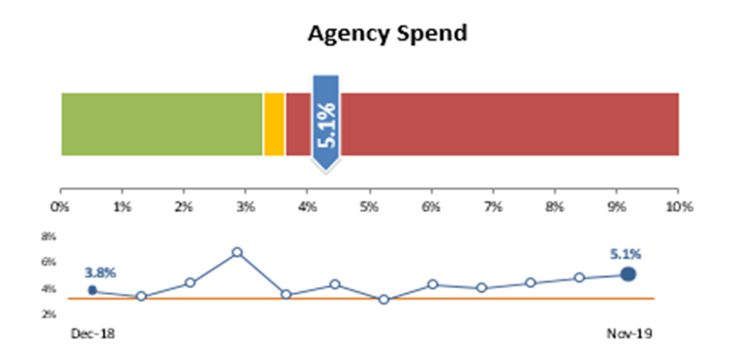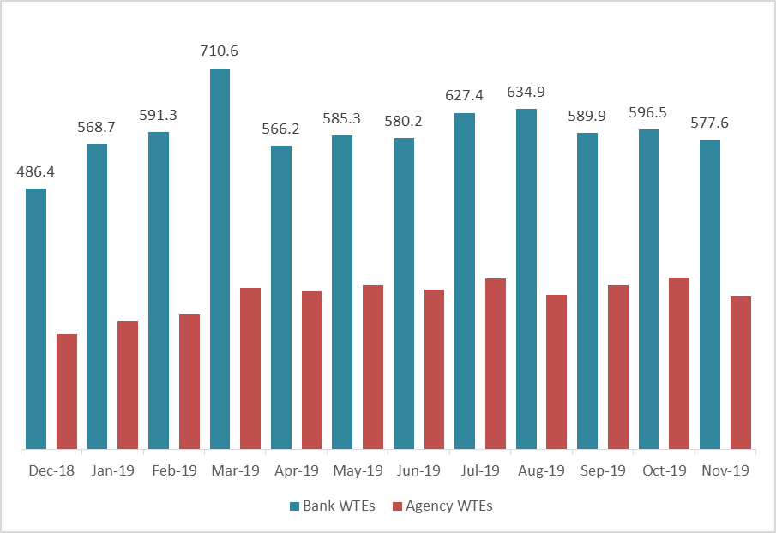  
 ***Table 12*** ***Table 13***

Table 13 highlights the actual usage of temporary staffing in October 2019 in comparison to each month in the preceding year. This is broken down into Bank and Agency WTE.

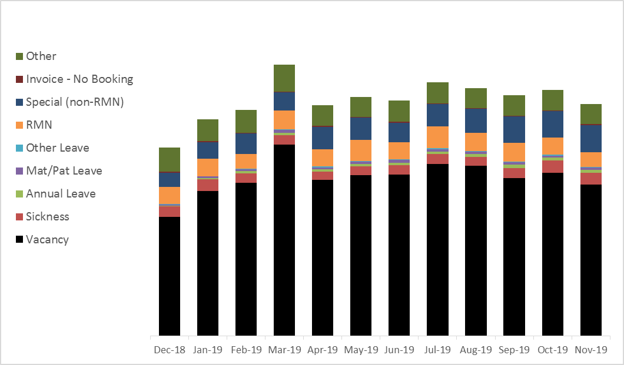

***Table 14***

Table 14 outlines the total temporary staffing usage, including the reasons for usage. As in previous months, there continues to be usage of temporary staff to support the enhanced care of patients, notably the ongoing use of RMNs.

**6.0** **Request to the Board of Directors**

The Board of Directors are asked to note the information contained in this briefing, including the increased number of staff in post, the use of the red flag system to highlight concerns on a daily basis, the reduction in annual turnover, the reporting of the roster KPIs and the ongoing development of the Nursing Associate programme at Guy’s and St Thomas’.