Referrals to be sent by email to: gst-tr.geneticsreferrals@nhs.net
Type of referral (circle preference): Is the patient terminally ill? Y/N
Rapid Routine *Has DNA sample been stored? Y/N

Patient details (failure to provide a working telephone number may result in rejection of referral):
Full name: Date of birth: NHS number:
Address:
Email:
Telephone number: Mobile:
Hospital number:
GP name: GP telephone number:
GP address:

Diagnosis and treatment plan:
Cancer type: Age of diagnosis: Previous primary cancer:
Other significant medical/surgical history:
Name of oncologist (if known): Please send a copy of the histology report/receptor status
Treatment details (dates are mandatory for rapid test requests. A failure to provide them will result in routine testing):
Tick as applicable | Treatment | Planned start date for treatment | Other details
 | Will chemotherapy be changed based on genetic result?
 | Will genetic result influence surgical management?
 | Will genetic result influence trial eligibility?

Genetic testing eligibility (tick as appropriate):
Female with breast cancer |  | Unaffected Female/Male | Ovarian/Uterine cancer | Male with BRCA related cancer | Pancreatic adenocarcinoma
 | Bilateral BC and both diagnosed <50 | FDR relative with breast or serous ovarian cancer and a family history with pathology- adjusted Manchester score ≥20. | Histology consistent with non-mucinous epithelial ovarian cancer  (serous, clear cell, endometrioid, mixed, undifferentiated, carcinosarcoma)  Serous uterine cancer | Male BC any age  Prostate cancer and a family history with pathology-adjusted Manchester score ≥15  Metastatic castrate resistant prostate cancer  Prostate cancer < 50 | Pancreatic adenocarcinoma <50  Pancreatic adenocarcinoma <60 AND BC/melanoma <60 or ovarian cancer  Pancreatic adenocarcinoma <60 and ≥ 1FDR with pancreatic adenocarcinoma <60  Pancreatic adenocarcinoma <60 and ≥ 2 FDR/SDR with any of BC <60, melanoma <60 or ovarian cancer
 | Triple negative BC <60
 | BC < 45 and a FDR with BC <45
 | Breast cancer <30
 | Triple positive breast cancer ≤35
 | Ashkenazi Jewish ancestry and BC any age
 | BC and a family history with pathology-adjusted Manchester score ≥15
First degree relatives (FDR): children, siblings, parents of patient Manchester score: guidance attached on page 2
Second degree relatives (SDR): grandparents, aunts, uncles on same side of family
Triple negative breast cancer: Quick score ≤3/8 for ER/PR & HER2-negative
Psychosocial Issues:

Referrer details:
Name and specialty:
Email: Telephone number:

I have discussed this referral with the patient Signature: Date:

The Manchester Scoring System
The Manchester Scoring System (MSS) allows the calculation of the probability for the presence of mutations in the BRCA1 and BRCA2 genes in families suspected of having hereditary breast and ovarian cancer (Evans et al, 2004).

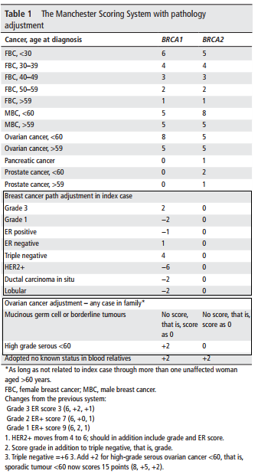
How to calculate the Manchester Score?
- Establish gender
- Establish cancer type in each affected relative
- Establish age at diagnosis
- For each relative with a BRCA related cancer, assign a score based on their age at diagnosis. (Example: woman with breast cancer aged 56 gets a score of 4, man with prostate cancer aged 44 gets a score of 2)
- If a relative has had more than one primary cancer, assign a score for each cancer episode. These cancers must not be recurrences or secondary cancers (Example: woman with breast cancer aged 32 and ovarian cancer aged 66 gets a score of 8+10 = 18)
- Do not assign a score for any mucinous and/or borderline ovarian cancers
- Adjust the score for pathology for the proband only. If the proband is unaffected, adjust for affected first degree relative
- Assess the maternal and paternal lineages as two separate entities
- Add up the scores for each affected relative with a BRCA related cancer on the maternal side
- Add up the scores for each affected relative with a BRCA related cancer on the paternal side
- You can allow one intervening female relative unaffected by cancer in the calculation
- You can allow more than one intervening female relative unaffected by cancer if one of them has had risk reducing surgery at an age less than 50
- If you would like assistance in doing this calculation please ring the on call cancer clinician on 02071881364

Reference: Evans DG et al, 2017. Pathology update to the Manchester Scoring System based on testing in over 4000 families. J Med Genet 54: 674-681

*How to organise the storage of a DNA sample?
- A 5ml blood in potassium sample (EDTA) can be collected locally and sent to our laboratory for storage
- If you would like assistance please ring the on call cancer clinician on 02071881364

